Journal Jin Yang

The project is to write a website for a small business that offers vehicles to be personalized and bought online. Professor have finished the part of code for state management, routing, and injecting data. Followed is my writeup for the project.

**Week 9, March 13 - Team splitting**

After the splitting of teams, we met each other and discuss about the project. We decided to separately go through all the code and requirements before diving into the process of final project. We also opened a slack channel for further use.

**Week 10, March 20 – Look and feel, Wireframes, sitemap**

After thoroughly checking the project, we draw the sitemap and wireframes of our website.



We discussed about the homepage together, and this is the wireframe of homepage.

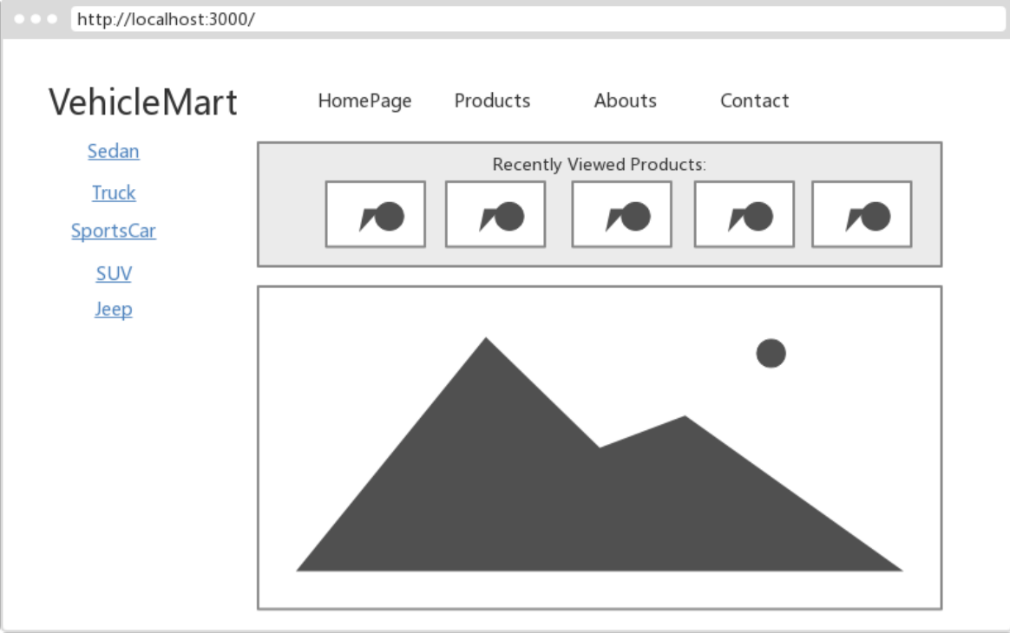

The original wireframe of product page looks like this, but we have made a few changes later. 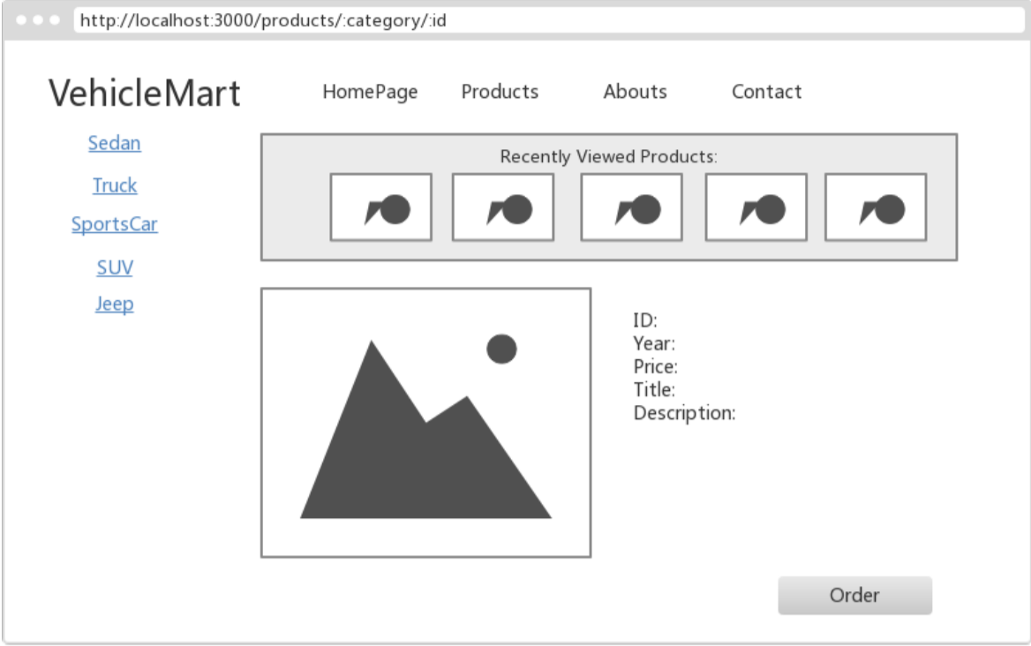

Since the order flow is a rather heavy part in the project, we decided to do it together. 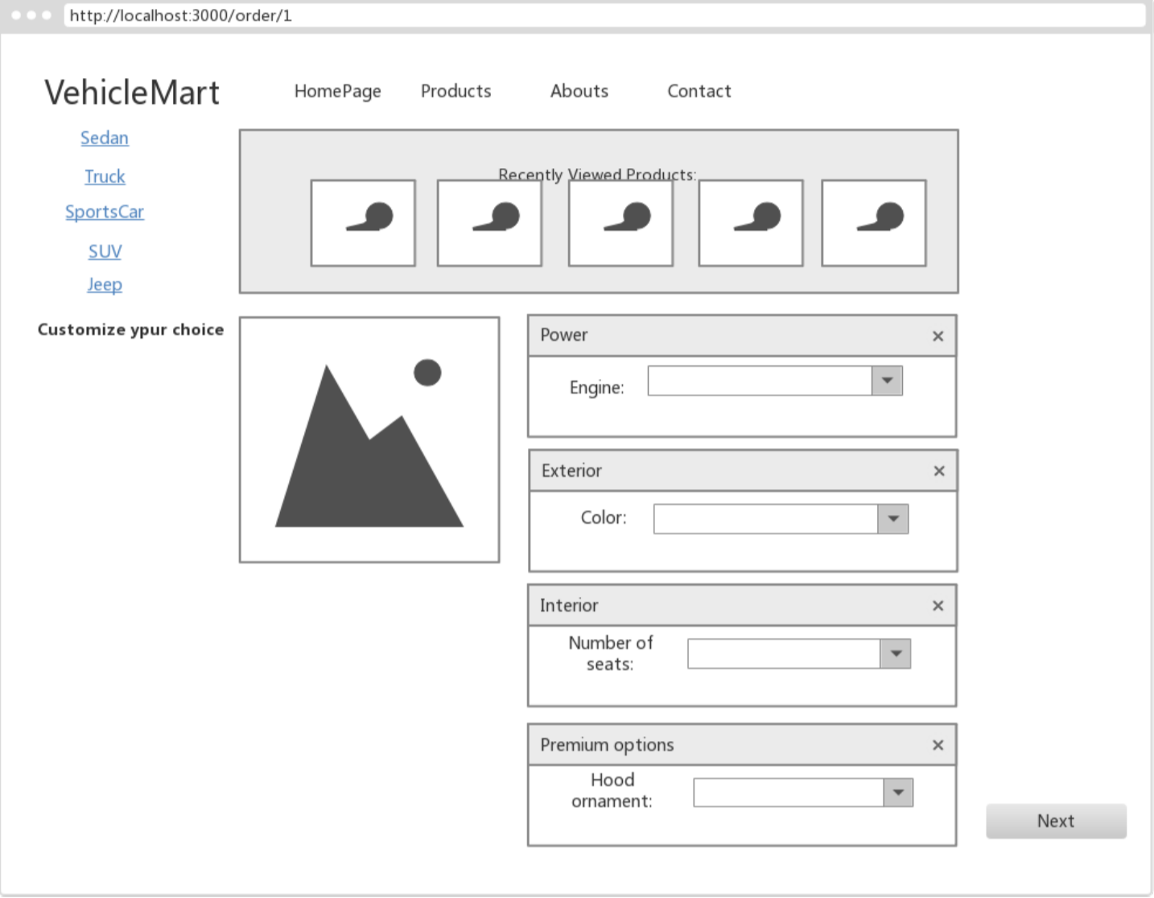

**Week 11, March 27 - Starting of project**

We decided to start with the order flow part of the project, since other pages like homepage, thank-you or 404 seems to be just some simple mortify of CSS file. YuXin and I am responsible for order step 2 and summary while other two members working on the step one.

To start with, I checked the wireframe we draw at the beginning of the project.

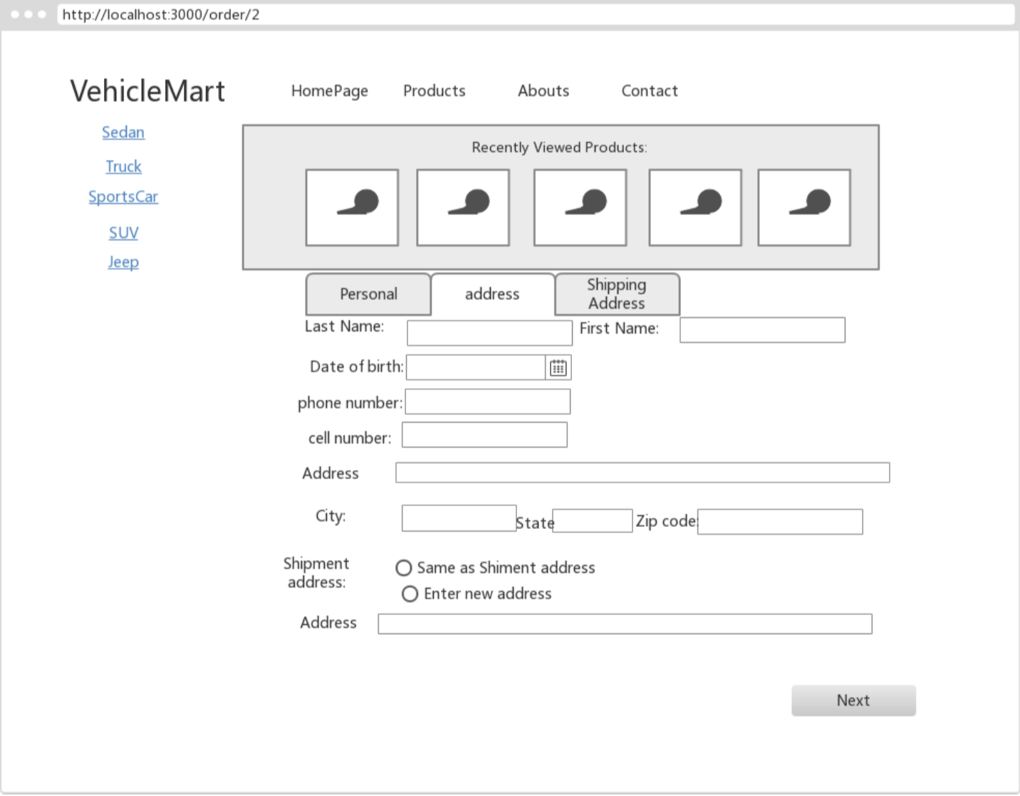

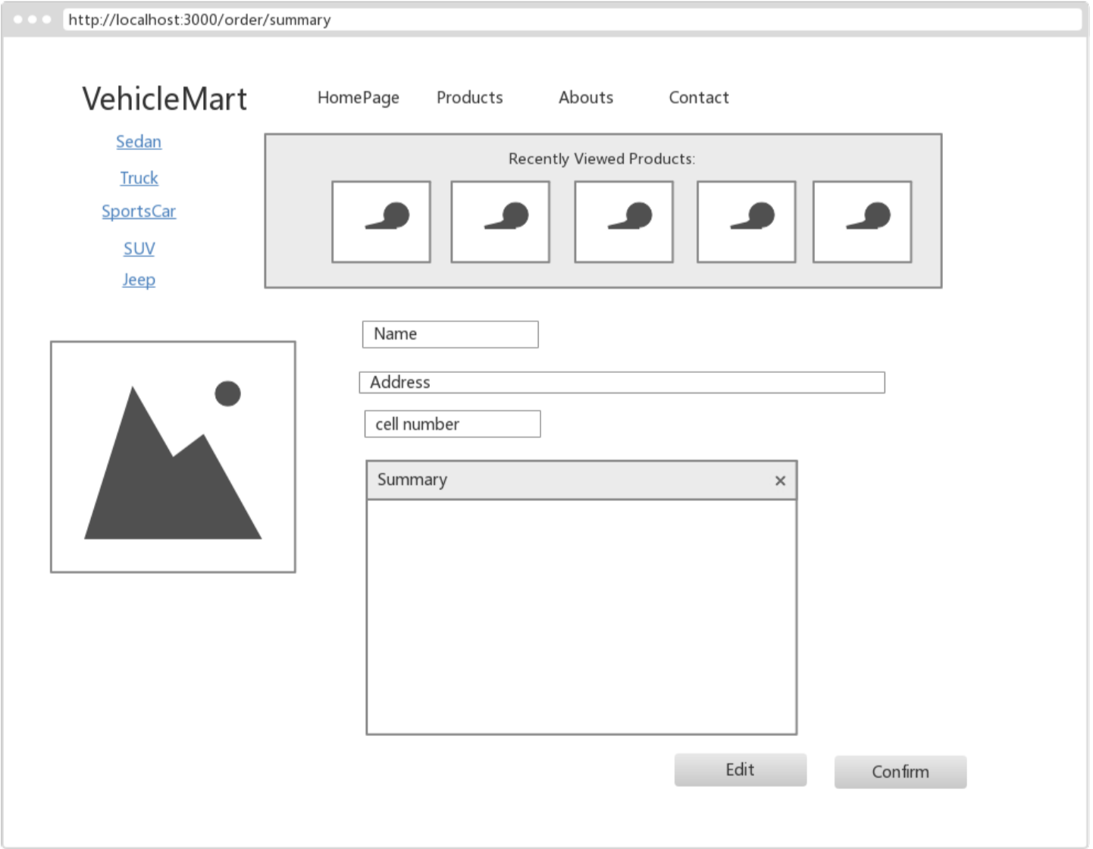

Based on the wireframe, I wrote the code for the two pages and added some CSS file. I knew it is better to work on the function first and then on the CSS file. But it felt much better to check a website with neat look than randomly distribute components, right?

**Week 12, April 3 – the changing point of project process**

At first, we separated the project based on the function, but then we found out that when two people are making changes at the same time or someone edit the CSS file, much time will be wasted on merging the code. Also, there is not much time left for us since the usability test is next week and we have not been working on the other pages. We then decided to each claim several pages so that we will not be modifying other people’s code. My responsibility is to do the order step 2 page as well as the summary page.

One of the few problem I need to work with is when user selects to use the billing address as shipment address, it will automatically fill in the form and the fields should be uneditable. At the beginning I thought I can manipulate DOM to change the value of the shipment address fields. However, after some searching I learned it is inappropriate to use querySelector in React. Also, I have thought about using refs attribute. Eventually, I put every change in state after reading the React Tutorial. This is the final effect of this part.

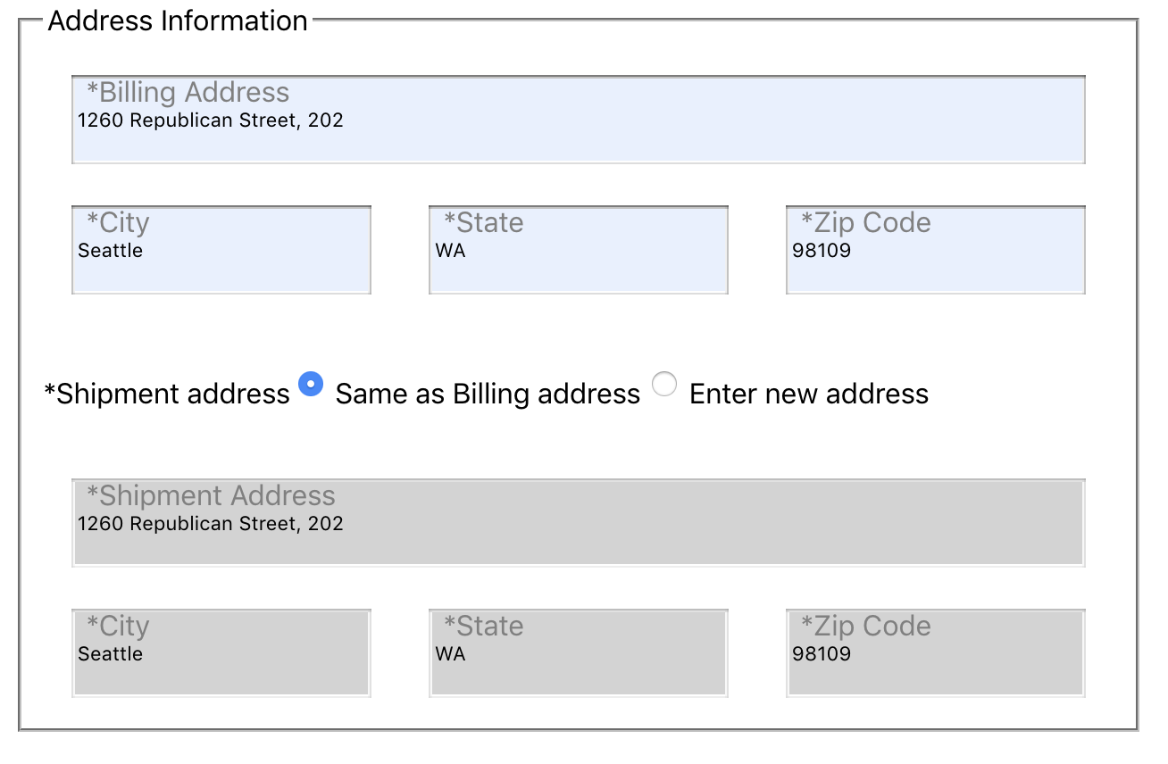

**Week 13, April 10 – usability test**

I have not realized the importance of usability test until I did one. One thing I learned is that users will not do exactly what you think they will do, and they will be affected by some stupid CSS and decide not to use your website!

This is the note for what I need to work on after usability test and group discussion.

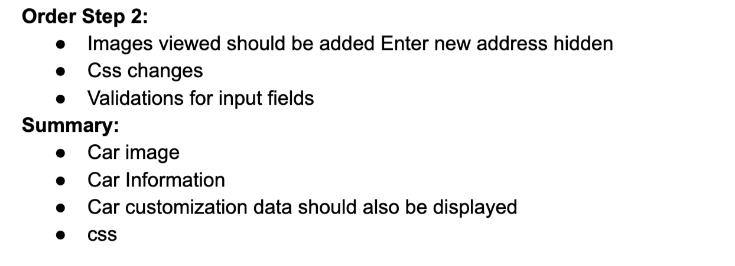

Validation is the most difficult part of the project from my point of view. First I think of using built-in form validation that HTML5 provided, but then I found that the use is limited and are unable to be customized. So I searched it online and self-learned regular expression and use it to validate the user input. Also, the error message will only appear when the user input is invalid. I implemented this by adding a variable in state and use conditional operator to decide whether to show it.

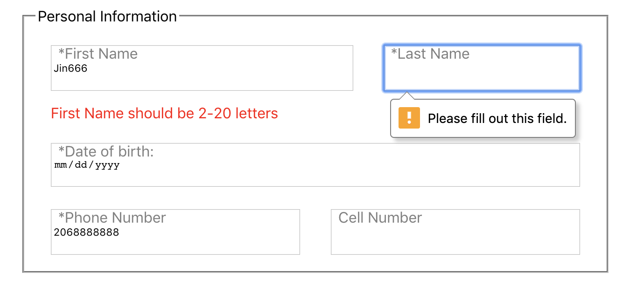

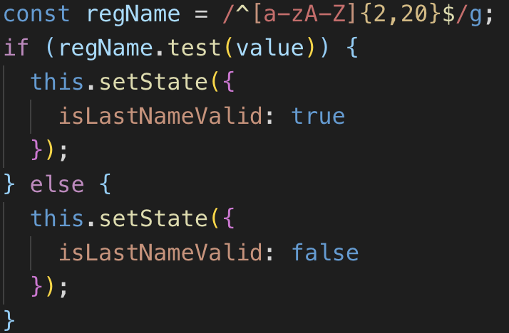

**Week 14, April 17 – final change**

Another problem I had was to display the information in the summary page. It was not until then that I realize that if CSS style is added to a label, it will be implemented to the entire project even though CSS module is used. After making changes in my module.css file, the display of other page was affected, so I rewrote all changes I made on labels.

**Summary**

Below is screenshots of order step 2 and summary:

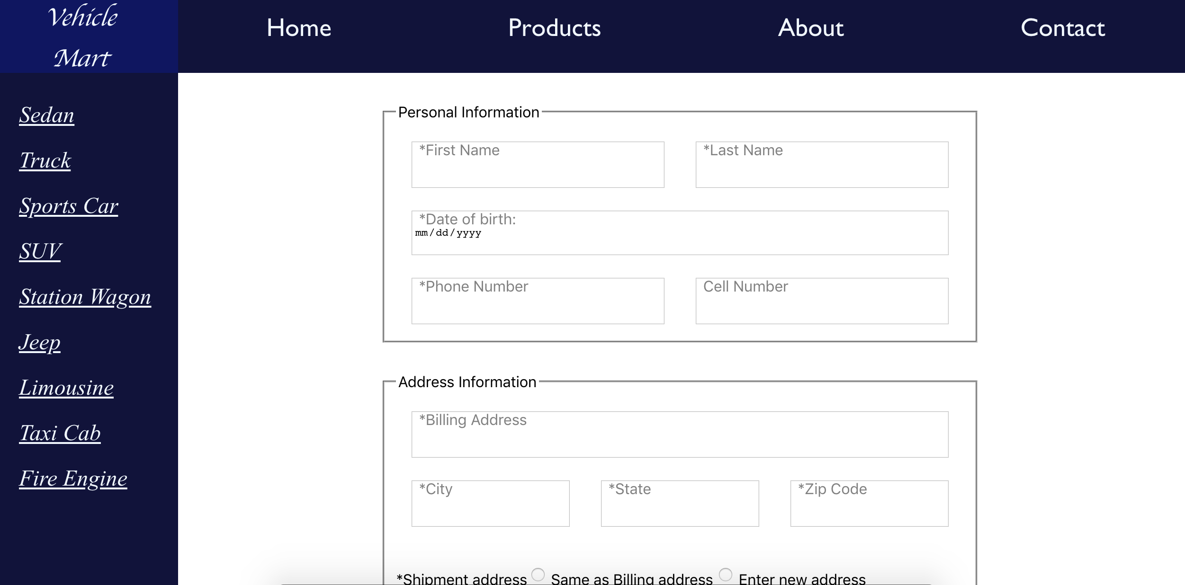

The header and footer are all inherited from the home page.

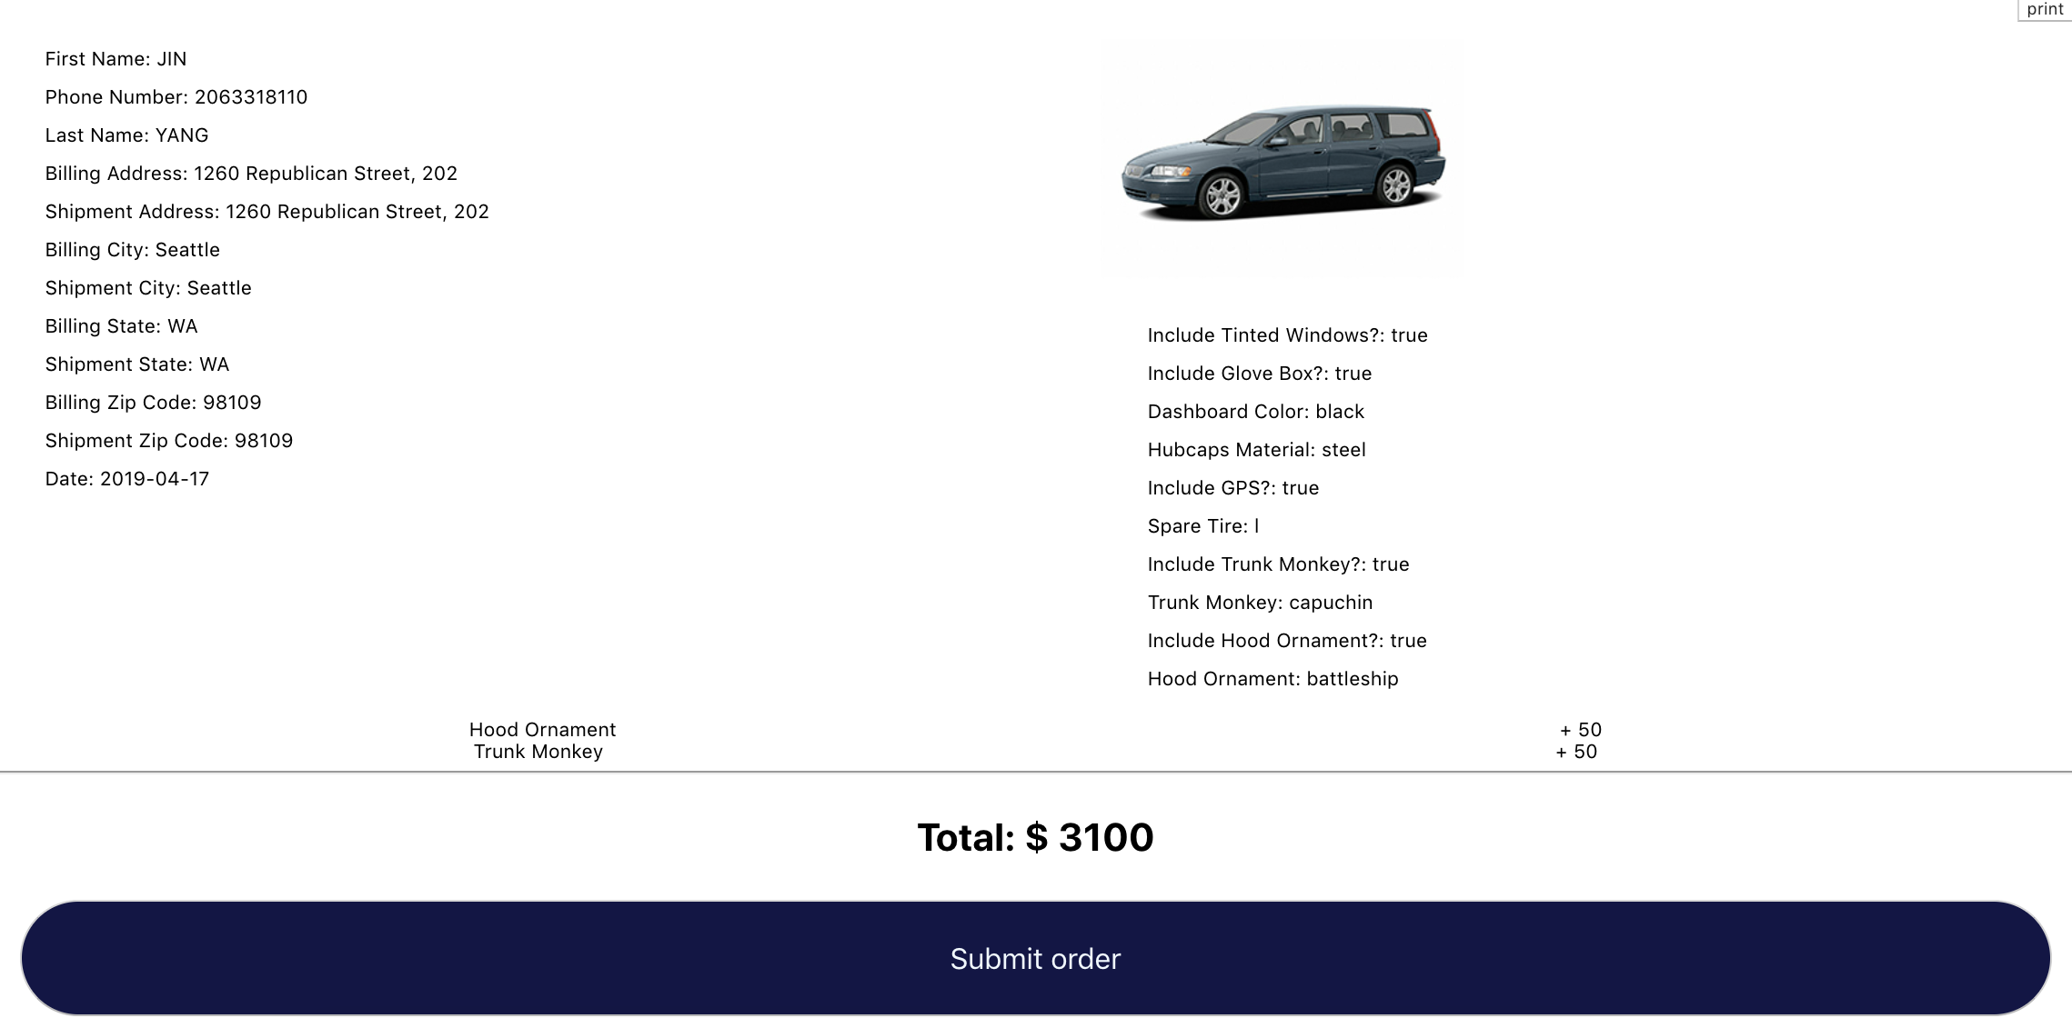

Although we do not need to write the connect logic for the project, I have read through the code professor gave us and I really have learned a lot. The use of bind function, react-redux, as well as react-router. This experience has taught me so much.

